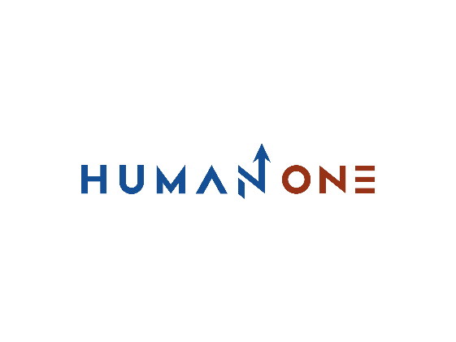

Services

Platform Development

Expertise

**EN**

**FR**

Get in touch

Company

# **Platform Development**



You want to renovate your technical architecture and be able to migrate from a rigid core system to a modular and agile ecosystem of connected layers powered by cloud architecture, microservices, and internal and external APIs?

With HumanOne's platform engineering expertise backed by your product vision, we can create a thriving ecosystem of integrated solutions and service providers so you can achieve economies of scale without being limited by production costs.

Let’s Talk



Online platforms beat product-only companies. That’s an axiom on which MIT researchers and HumanOne platform developers strongly agree. From the automotive to real estate sectors, we’ve already helped an array of market leaders launch new B2C digital platforms and scale B2B platform as a service offering, positioning our clients miles ahead of the monolithic competition. Our digital platform services cover all your needs. From digital platform consulting to development infrastructure setup and subsequent platform orchestration, we can help your company build a strong but scalable technological backbone to support an array of internal solutions and external ecosystem participants.

**Digital platform design & development**

Design the optimal architecture of the digital platform and bring it to life.



**Security and assurance**

Leverage the cybersecurity expertise of our digital platform specialists to mitigate risk.

**Platform maintenance & support**

Enjoy the network effect without worrying about degradation or downtime.

**Data engineering**

Get help with data center consolidation and resource optimization to break down data silos.

**Platform governance**

Manage your ecosystem with centralized control mechanisms and real-time visibility.

**Infrastructure/IT services optimization & automation**

Land in the cloud without technical debt by eliminating, automating and consolidating.

**API & System Integration**

Enable efficient data exchange and communication between all services of the digital platform.



Let’s start your platform development process

Get in touch

## **Reasons for choosing HumanOne**

**Cross-industry domain knowledge**

From Fortune 500 companies to pioneering market entrants, HumanOne provides PaaS consulting and digital platform development services to companies at different stages of their market and digital journeys. We know how to approach problems from unexpected angles and translate them into custom solutions for our clients.

**Profound big data expertise**

Platform solutions thrive thanks to advanced data analytics running atop secure data management platforms. HumanOne big data engineers can help you make better sense of the data you own, the data you need to procure from siloed systems, and the operational insights trapped within.

**Iaas and Paas consulting services**

Leverage our deep platform engineering expertise with various cloud computing platforms, vendors, and services. Together, we can assemble a winning multi-cloud portfolio to host your platform infrastructure. Plus, assist with cloud migration and legacy application refactoring for new environments. Gain speed, scale, and TCO savings.

### **Platform orchestration & DevOps expertise**

The success of digital platforms is the grand sum of inputs from platform partners. Ensure that every system, process, and API facilitates rather than hinders your growth by leveraging our team’s IT orchestration expertise. Our DevOps consultants can help you augment your delivery with CI/CD and continuous testing.

**Solid AI and ML skillset**

Give your digital platform solutions an edge over the competition with integrated AI and ML models. Our R&D team composed of skilled data engineers and ML specialists will work out the optimal set of scientific models to power your intelligent algorithms. Automation, prediction, personalization, or something else? We can build a model for that.

**Ingenious UI/UX designers**

Platforms grow stronger with more users. However digital technology platforms with clunky interfaces have a hard time growing their customer base. That won’t be the case with your platform, though. Our UI/UX design team integrates into the platform development process to ensure a stellar UX across all customer touchpoints.



